Assignment – 08:
Problem Statement: Deploy a project from Local Machine to GitHub and vice-versa.
Steps:
- The GitHub website is opened in a web browser and the user is signed in using valid credentials. If an account does not exist, a new account is created. 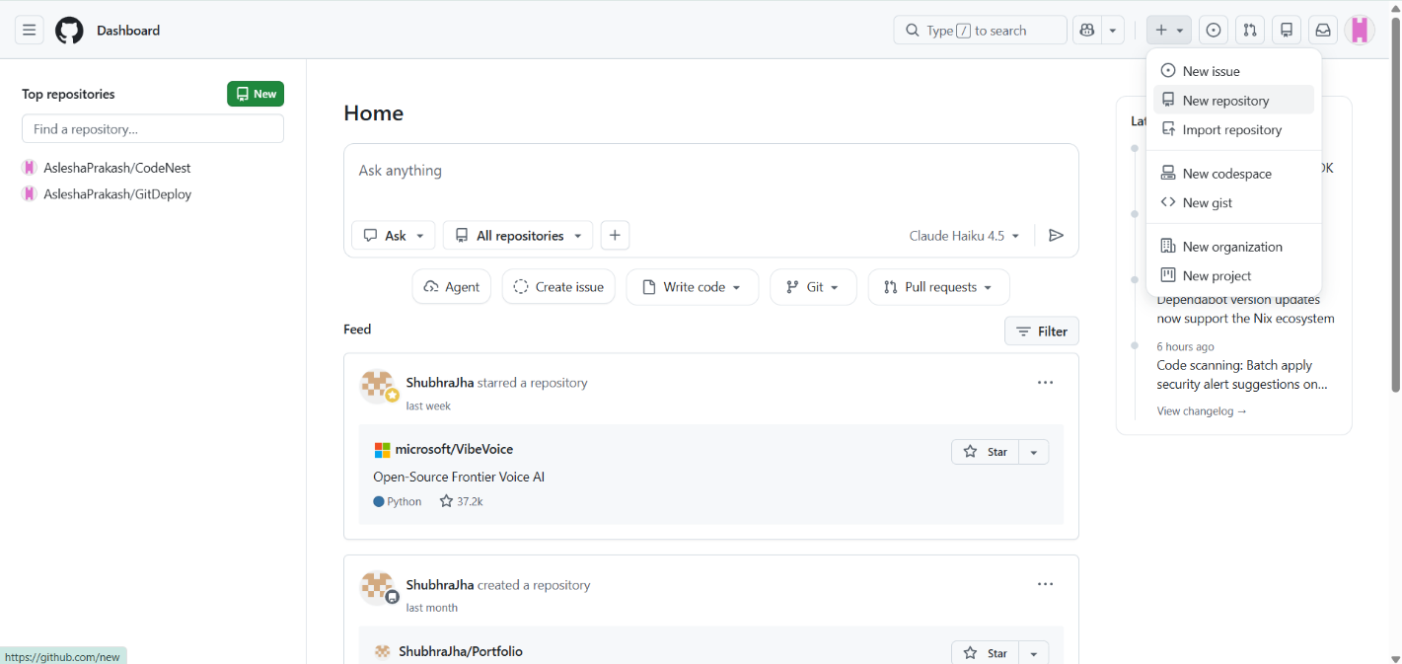

- A new repository is created by clicking on the “New Repository” option. A suitable repository name is provided, and the repository visibility is selected (public/private). The repository is then created successfully. 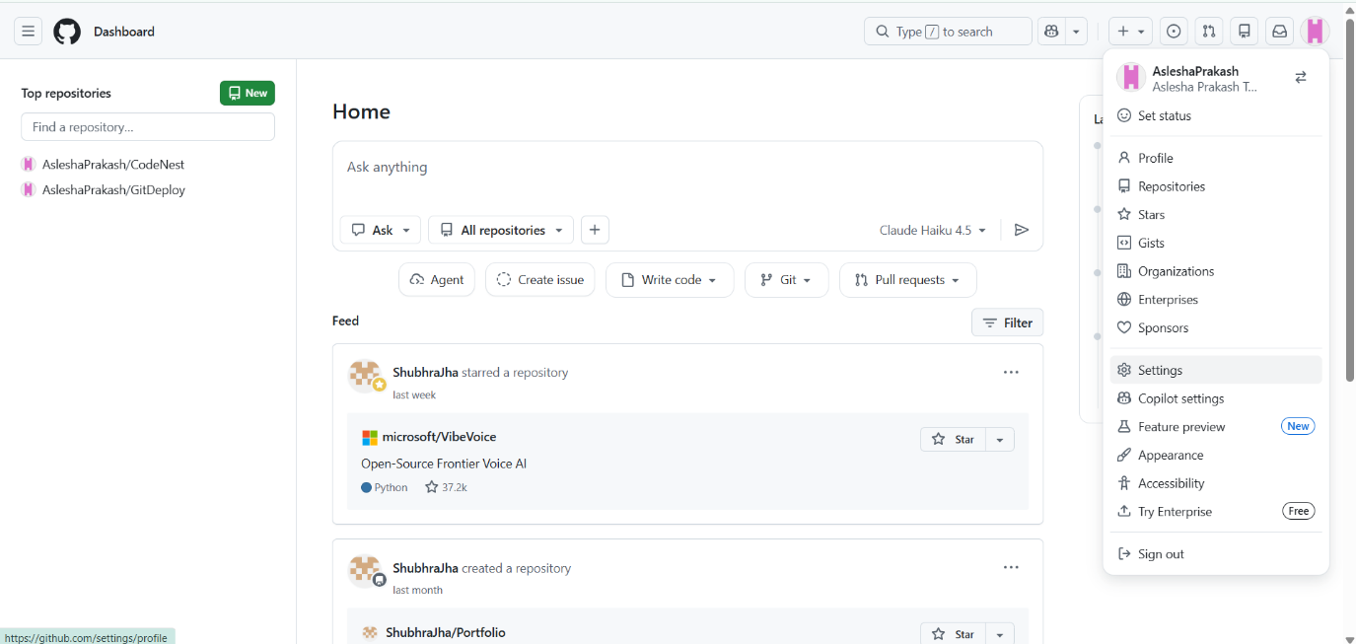

- For authentication via the terminal, a Personal Access Token (Classic) is generated within the GitHub "Developer Settings". All required scopes are selected, and the generated token is securely saved.
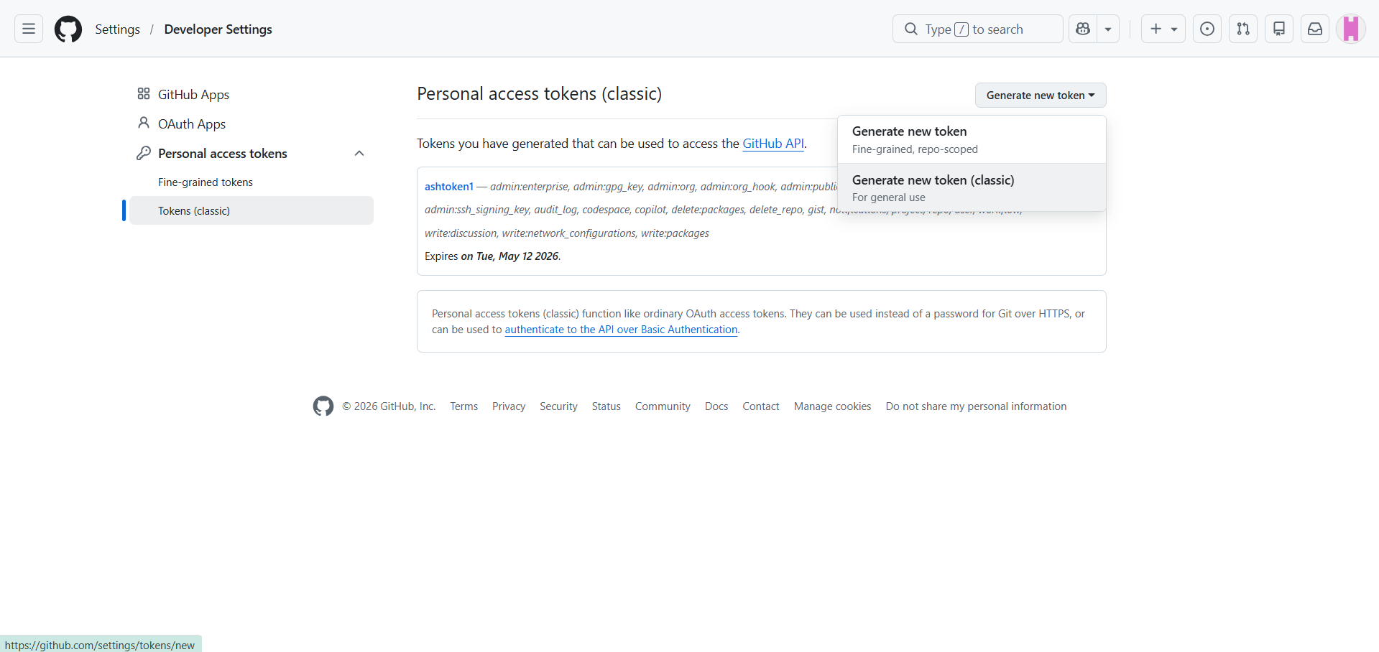
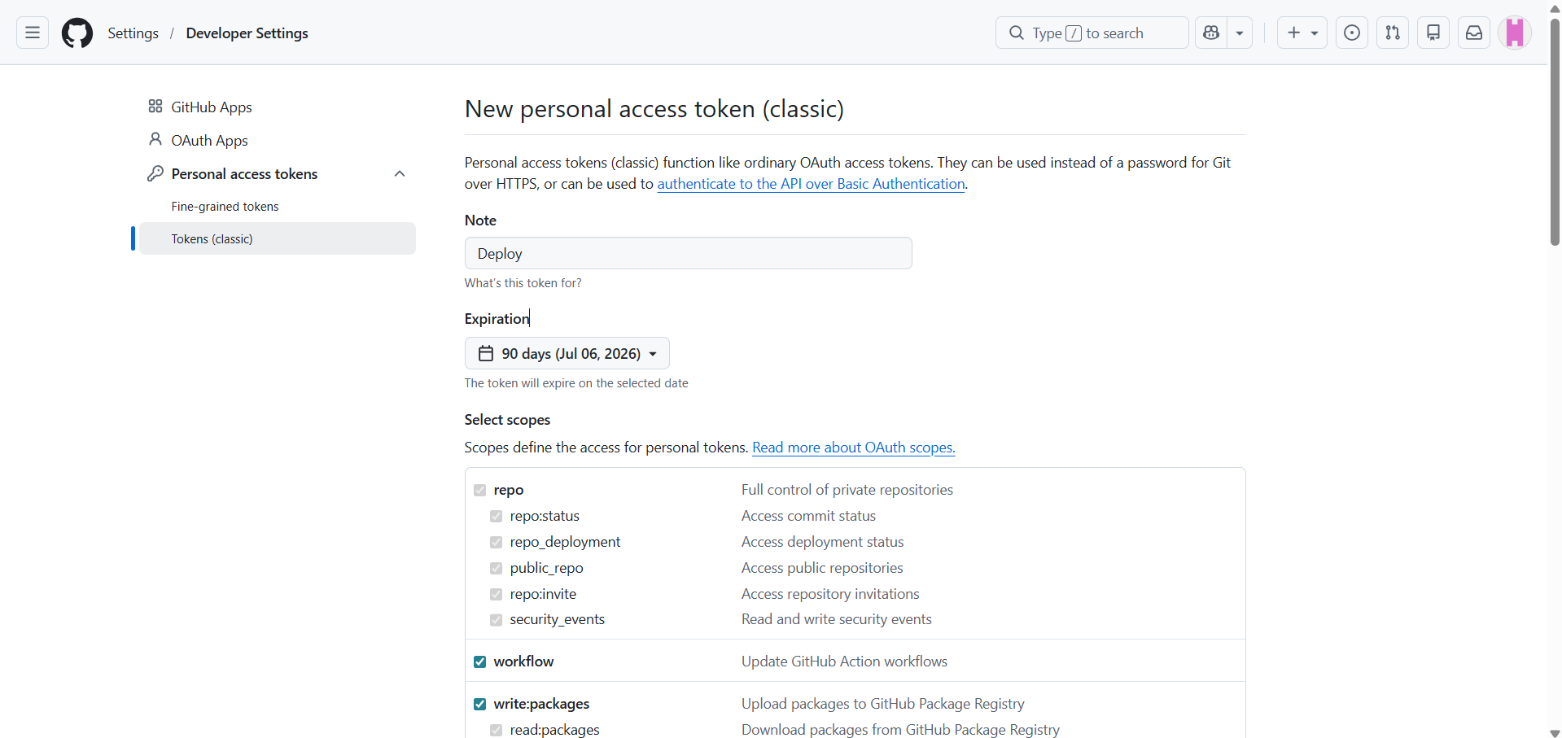
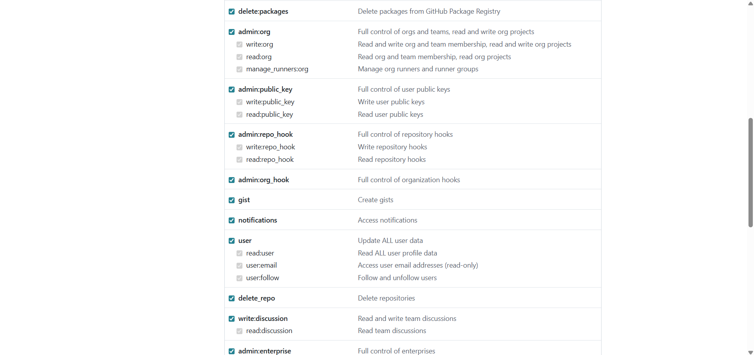
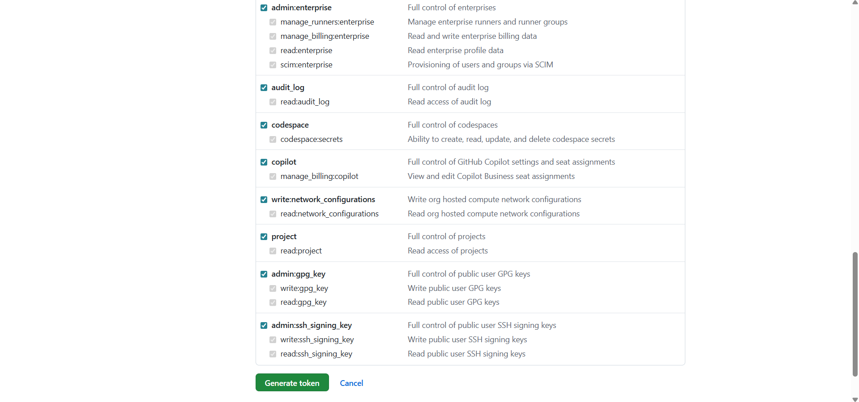

- A local folder is created, and the Git Bash terminal is opened within that directory.
- The selected folder is initialized as a Git repository using the following command:
  - git init
  - git clone https://github.com/AsleshaPrakash/CodeNest.git
  - ls -A
  - rm -r .git/
  - ls -A
  - cd CodeNest/
  - ls -A
  - rm -r .git/
  - rm -r .gitignore
  - ls -A
  - cd ..
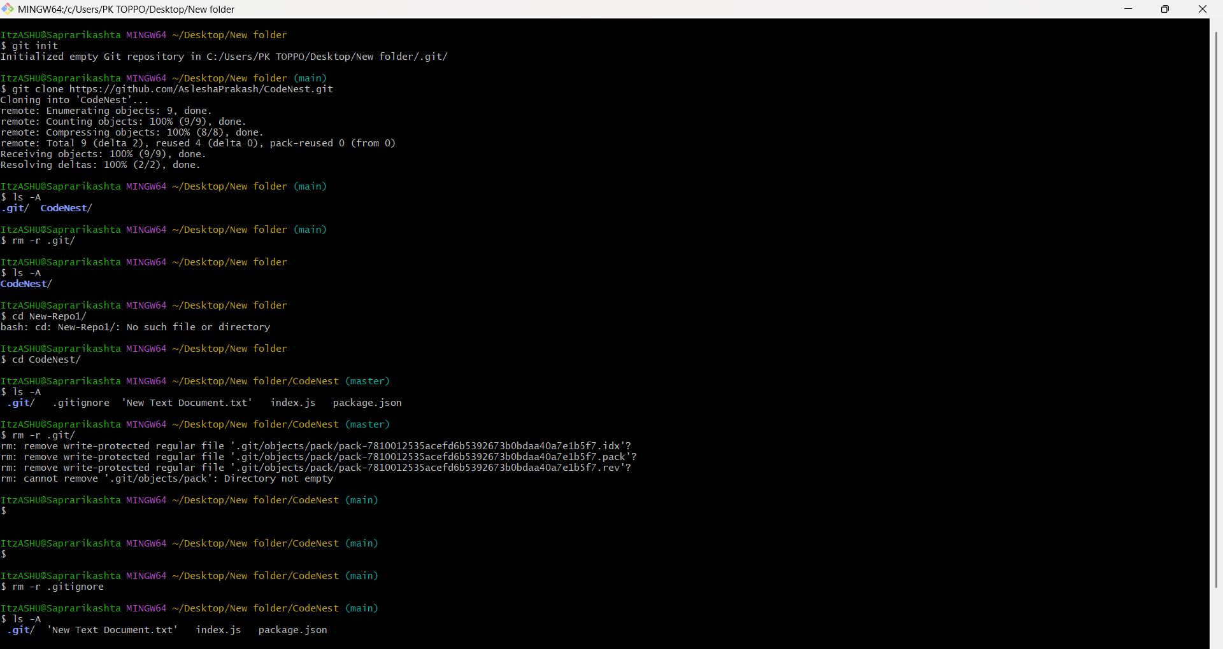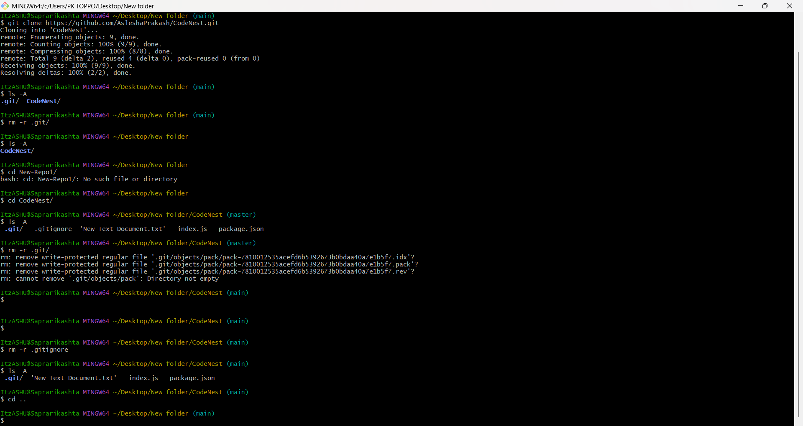

- The terminal is closed and the folder in which the project was cloned is opened. The CodeNest folder is single-clicked and, by right-clicking, the “Git Bash Here” option is selected.
- A Git Bash terminal is opened again. The following commands are entered to upload the cloned project to the created GitHub repository:
  - git init
  - ls -A
  - git status
  - git config --global user.email “Your email here”
  - git config --global user.name “Your GitHub account username here”
  - git config user.name
  - git config user.email
  - git add .
  - git status
  - git commit -m “type your own message here”
  - git remote add origin https://github.com/yourusername/Yourrepositoryname.git
  - git push -u origin master
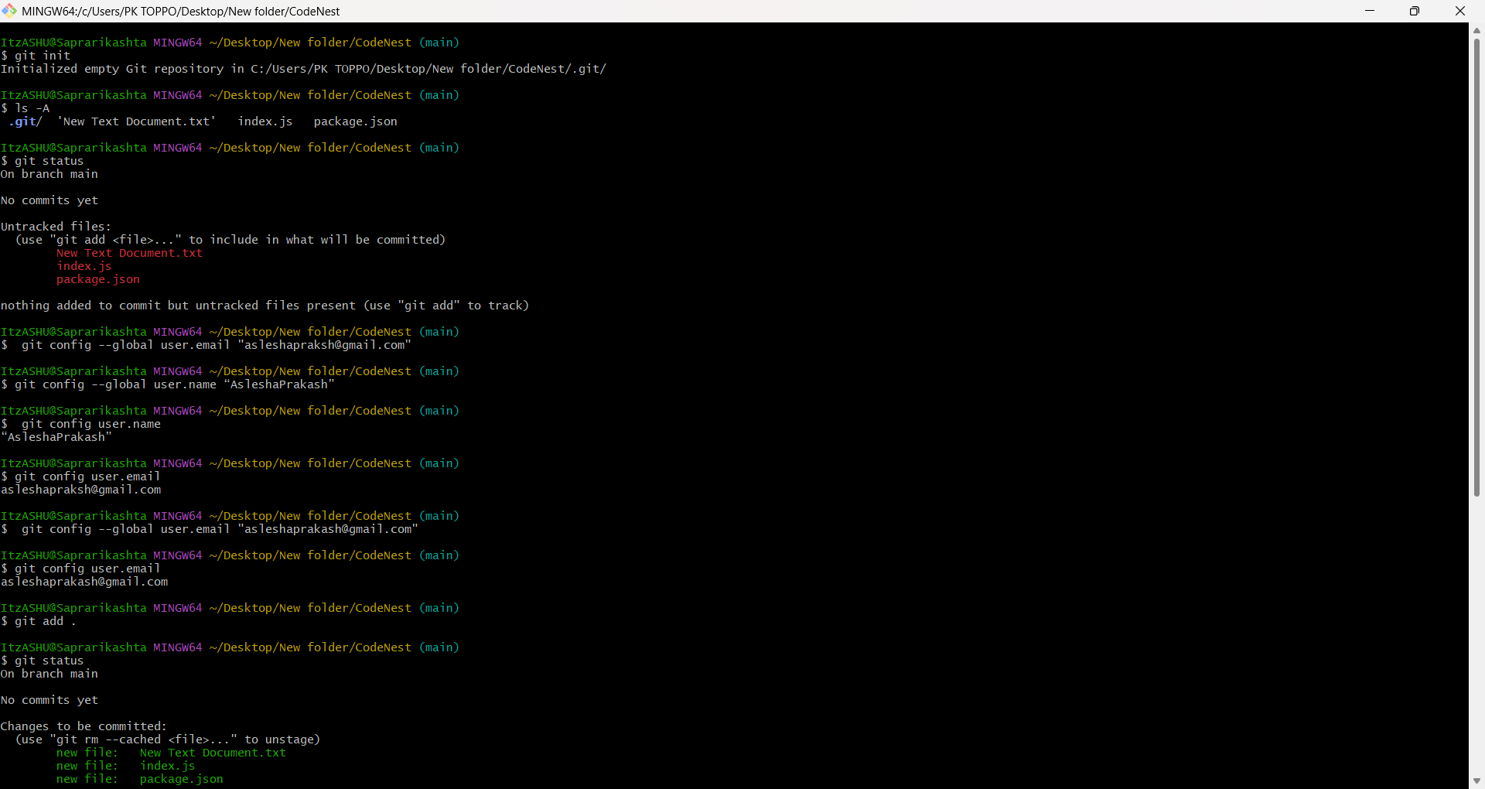
- The browser in which the GitHub repository is open is accessed, and the page is refreshed. The uploaded files are then visible in the repository. Thus, the project has been successfully cloned and uploaded to GitHub using Git and Git Bash terminal.
- Collaborators can also be added to provide access to the private repository and allow contributions.
  - The Settings section of the repository is opened from the navigation bar.
  - The Collaborators option is selected from the left navigation panel. The password is entered when prompted.
  - The “Add people” button is clicked to add collaborators to the repository. The users are searched by their username or email
